Personal Packing List 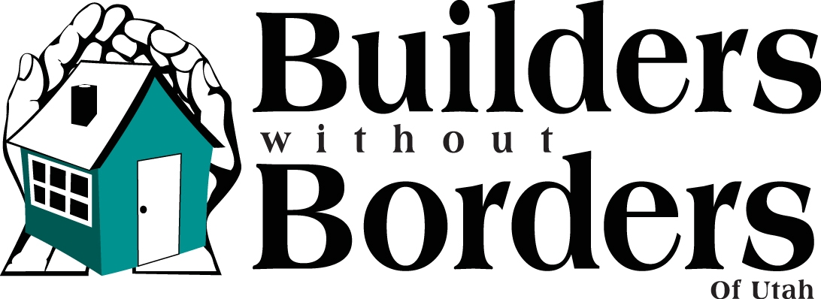
**PASSPORT**** or copy birth certificate (if under the age of 16)**
Clothing
- Work clothes for 6 days (old t-shirts, old jeans, and at least one long-sleeve shirt that can be thrown away after stuccoing)
- If working mostly humanitarian projects at the church, bring comfortable casual clothes.
- Jacket or Coat, it will be chilly at night
- Sweat shirt or hoodie
- Poncho or rain gear you can work in(the rain is SO wet in Mexico)
- 1 Sunday outfit for church or missionary splits (probably a white shirt for males)
- Clothing for traveling and evening use
- Pajamas, sweats, or other comfortable attire for evening use (plan on no privacy ☺)
- Swimming suit for outdoor shower
- Robe or cover-up for walking to and from outdoor shower
- Towel, wash cloth
- Underwear and socks for 8 days
- Slippers or sandals for evening use (we don’t recommend ever being bare footed!)
- Sunday shoes, travel shoes, flip flops for showering, work boots, heavy shoes, or sturdy tennis shoes for working in
Personal Hygiene Items
- Tooth paste, tooth brush
- Comb, brush, etc. and for women: rubber bands or clips to keep hair out of your way while working
- There will be electricity for blow dryers and curling irons if you want
- Make-up for Sunday (the rest of the week, believe me, you’ll be too tired to care)
- Lotion, lip balm, sunscreen
- Baby wipes while on the job site
- Shampoo, conditioner, soap
- Eye care
- Prescriptions and over the counter medications like Vitamin C, Tylenol, Tums, Advil, anti-diarrhea pills, etc.
- Personal first aid kit
- Feminine hygiene products (tampons are almost impossible to find) EVEN IF IT’S NOT “THAT TIME” just bring “in case”
- Razor, fingernail clippers, tweezers
Misc.
- Safety glasses for job sites, sunglasses, duct tape & permanent marker (to mark tools, items etc)
- Work gloves
- 25’ tape measure and pencil
- Hammer, tool belt(cheap fabric one from home depot is great) and other personal tools
- Scriptures, Journal and pen
- Small games like UNO, cards, etc. for evening use
- Camera (digital is best so we can share pics)
- Sleeping bag or sheets and blanket, pillow
- Cot, pad, or blow-up mattress/mattress inflator
- Watch with an alarm or small travel alarm clock
- Ear plugs and/or eye mask if you are a light sleeper..there is a good chance some snorers will be in the room you’re sharing!!!
- ****PASSPORT or copy birth certificate, if under the age of 16**** ☺ LOL
- Case(s) of water. We will have filtered water at the church so you can refill water bottles, but it sometimes takes a day or two for the water to be delivered to the church and you will want these on the job sites. DO NOT pack water in the trailers. Keep these with you. These can also be purchased in Mexico at the grocery stores.
- 1 box of cereal per participant, 1 box of granola bars/fruit bars, 1 package of cookies and 1 box of crackers, 1 bottle of jam or jelly, 1 roll of paper towels and 2 large black garbage bags. These items are to help provide breakfasts & snacks and for the upkeep of the building.

Helpful Hints:
- Now, here’s the fun part: Each person is allowed 2 bags and an overnight bag. The 2 bags we will pack in trailers and you will not see again until we unpack at the church in Mexico. The overnight bag will travel with you to Mexico. Label or mark your bags for easy identification. No loose items will be packed in the trailers. Keep breakable items with you.
- DO NOT bring anything you’re not willing to have stolen, broken or lost. It is not a good idea to bring expensive electronics, jewelry, etc. Don’t be a flashy target for thieves.
- There will be very little privacy at the church. So, please dress modestly.

